CHOOSING RELIABLE SOURCES
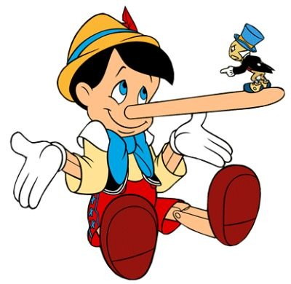

When doing academic research, one must be able to weed through an abundance of misinformation before finding CREDIBLE information, that is, RELIABLE SOURCES. Here are some tips for how to find those sources and how they are best used.
- Who Wrote It? Look for sites with expertise, you wouldn’t go to an auto mechanic if you needed help with heart medication. Is the author an expert? Research their education or experience. Search for their biography or any published works. Avoid “anonymous” authors.
- Look for sites from Established Institutions Anyone can make a website. Look for sites that are associated with trusted institutions that have a track record for reliability and integrity. Such sites may include those run by government agencies, non-profit organizations, foundations, or colleges and universities. . If you doing research on a measles outbreak, consider sites like The Center For Disease Control.
- Check the Domain Look at the last three letters of the site’s url.
.com = commercial May be a good source, such as history.com, but do
some investigating for signs of reliability
.edu = educational Generally credible and scholarly.
.gov = government Generally credible and scholarly.
.org = nonprofit May have good information, but expect anything on this site to have bias toward the organization’s mission or goals.
- Start with Sites You Know There may be better information out there, but starting with a source you already trust is a good way to narrow your search. Then, if you do decide to look up information from other sources, you can compare it to what you found first.
- Check the Date An outdated source is often no longer credible. Dates should be recent or, in some cases, near the time the content became known.
- NO Wikipedia Wikipedia offers a large volume of information, but because its entries are created in a collaborative effort involving many different users, its reliability can vary widely. In some cases, users deliberately place incorrect information on the site; in others, well-meaning users unintentionally introduce inaccuracies. For these reasons, you can use Wikipedia as a jumping-off point to spark more research, but not as a source on its own.
- Dig Deeper- Be A Detective! Read other articles, particularly by the same authors. Do you trust their opinions on other topics?
Check the spelling- misspellings can be a clue that this is not a credible source.
Don’t trust your first source- read multiple sources on the same topic to see if the information in consistent and reliable. Scholarly sources will have references or source information- check/use them!
PURPOSE FOR USING RESOURCES
BACKGROUND INFO | Books or Encyclopedias | To obtain broad information about a topic of issues related to the topic.
CURRENT EVENTS | Newspapers, magazines, social media, television. | Explores why an issue matters and who is impacted, provides up-to-date information, applies chronology.
DATA AND STATISTICS | Gov’t websites, non-profit websites, research studies | Quantifies impact, explores the extent of an issue
ANALYSIS  AND OPINION | Magazines, Editorials, Online Essays, News Sources, Blogs | Explores pro/con arguments, can help get a persuasive essay started or form a thesis, presents different interpretations of a complicated issue.
RESEARCH | Scholarly Books and Journals | Presents original research and experiments conducted by EXPERTS within a field of study.

